# Rapportage standardisé cavité orale

Conclusion

**Thérapie néoadjuvante :** Choisissez un item.

**Localisation tumorale :**

**Lèvre** : Choisissez un item.

**Cavité orale** : Choisissez un item.

*Si autre, spécifiez :*

**Latéralité** : Choisissez un item.

**Focalité:** Choisissez un item.

*Si multifocal, spécifiez le nombre de foyers:*

*Si ne peut pas être évaluée, spécifiez :*

**Dimensions de la tumeur** : Choisissez un item.

Dimension maximale de la tumeur (en mm) :

*Si ne peut pas être déterminée, spécifiez :*

**Type histologique de la tumeur[1] :** Choisissez un item.

*Si possible, spécifiez le type :*

**Degré de différenciation :** Choisissez un item.

*Si non évaluable, spécifiez :*

**Worst pattern of invasion (WPOI):** Choisissez un item.

**Profondeur d’invasion[2] :** Choisissez un item.

Profondeur d’invasion exacte (en mm) :

*Si non évaluable, spécifiez :*

**Schéma d’invasion** : Choisissez un item.

**Extension locale** : Choisissez un item.

*Si une extension locale a été démontrée :*

Invasion osseuse[3] : Choisissez un item.

Invasion de la peau du visage/cou : Choisissez un item.

Invasion du plancher de la bouche (lèvre) : Choisissez un item.

Invasion du sinus maxillaire (cavité orale) : Choisissez un item.

*Si l’extension locale ne peut pas être évaluée, spécifiez :*

**Invasion lymphovasculaire** : Choisissez un item.

*S’il est possible de différencier entre invasion des vaisseaux lymphatiques et sanguins, spécifiez :* Choisissez un item.

*Si non déterminée avec certitude, spécifiez :*

**Invasion périneurale[4]** : Choisissez un item.

*Diamètre de la plus grande cellule nerveuse affectée (en mm):* Choisissez un item.

*Si non déterminée avec certitude, spécifiez :*

**Marge minimale définitive saine - carcinome invasif**

**(y compris les éventuelles résections ultérieures et sections congelées)[5] :** Choisissez un item.

Marge minimale définitive saine (en mm) :

Précisez plan de coupe le plus proche, si possible :

*Si non évaluable, spécifiez :*

**Marge minimale définitive saine – dysplasie sévère/carcinome in situ**

**(y compris les éventuelles résections ultérieures et sections congelées)[6]:** Choisissez un item.

Marge minimale définitive saine (en mm) :

Précisez plan de coupe le plus proche, si possible :

*Si non évaluable, spécifiez :*

**Classification pTNM (8ème édition du TNM de l’UICC, avec errata)[7] :** **pT** Choisissez un item.

Préfixes :

m (multiples tumeurs primaires) : Choisissez un item.

r (récidive) : Choisissez un item.

y (après thérapie néoadjuvante) : Choisissez un item.

Champ d’application

Echantillons de résections et de biopsies excisionnelles de tumeurs malignes de la cavité orale, y compris la muqueuse de la lèvre et de la langue (carcinomes des muqueuses, tumeurs malignes des glandes salivaires accessoires).

Remarques

* Les biopsies incisionnelles et autres échantillons de biopsies ne sont pas inclus dans ce dataset.
* Pour des résections relatives à des récidives, le dataset peut être utilisé de manière pragmatique, même si certaines variables peuvent ne pas être applicables ou évaluables.
* Le mélanome muqueux, les lymphomes et les sarcomes sont traités dans des dataset distincts.
* Les néoplasmes neuroendocrines sont traités dans un dataset distinct.
* Les dissections du cou et les excisions ganglionnaires sont traitées dans un dataset distinct. Si applicable, l’utilisation de ce dataset doit être combinée.
* Pour des tumeurs indépendantes supplémentaires (multicentriques), un dataset distinct doit être rempli pour chaque tumeur.

Dataset basé sur

Müller S, Day TA, Griffith CC, Magliocca KR, Mori T, Richardson MS, Sloan P, Tilakaratne WM, Zain RB, Helliwell T, Thompson LDR (2024). *Carcinomas of the Oral Cavity Histopathology Reporting Guide. 2nd edition*. International Collaboration on Cancer Reporting; Sydney, Australia. ISBN: 978-1-922324-45-0.

Informations complémentaires[8]

**Note 1 –Tumour site**

The anatomy and surgical interventions of the oral cavity are complex, and it is important to ensure accurate and precise communication between the pathologists and the treating and diagnostic team with respect to exact anatomic site of involvement, tumour laterality and specific operative procedures.9-11

The protocol applies to all carcinomas arising at these sites (see Figure 1). For large cancers that involve more than one site, the primary site of involvement should be recorded.

Mucosal Lip. Begins at the junction of the wet and dry mucosa (vermilion border) that comes in contact with the opposing lip. The dry vermilion lip and vermilion border are staged using the cutaneous dataset.12

Buccal Mucosa (Inner Cheek). Mucous membrane lining of the inner surface of the cheeks and lips of contact of the opposing lips to the line of attachment of mucosa of the upper and lower alveolar ridge and pterygomandibular raphe.

Lower Alveolar Ridge. Mucosa overlying the alveolar process of the mandible, which extends from the line of attachment of mucosa in the buccal vestibule to the line of free mucosa of the floor of the mouth.

Posteriorly it extends to the ascending ramus of the mandible.

Upper Alveolar Ridge. Mucosa overlying the alveolar process of the maxilla, which extends from the line of attachment of mucosa in the upper gingival buccal vestibule to the junction of the hard palate. The posterior margin is the upper end of the pterygopalatine arch.

Floor of the Mouth. Semilunar space over the mylohyoid and hyoglossus muscles, extending from the inner surface of the lower alveolar ridge to the undersurface of the tongue. The posterior boundary is the base of the anterior pillar of the tonsil. It is divided into two sides of the submaxillary and sublingual salivary glands.

Hard Palate. This is the semilunar area between the upper alveolar ridge and the mucous membrane covering the palatine process of the maxillary palatine bones. It extends from the inner surface of the superior alveolar ridge to the posterior edge of the palatine bone.

Anterior Two-Thirds of the Tongue (Oral Tongue). The freely mobile portion of the tongue that extends anteriorly from the line of circumvallate papillae to the undersurface (ventral) of the tongue at the junction of the floor of the mouth. It includes the tip of tongue, lateral borders, dorsal surface and ventral tongue. The ventral tongue is listed as a separate tumour site in the ICCR reporting guide.

Retromolar trigone. A triangular shaped region extending distal from the mandibular third molar as the base and attaches to the hamulus of the medial pterygoid process of the sphenoid bone as the apex.

‘Not specified’ should be used rarely and only after good effort has been employed to obtain the requisite information.

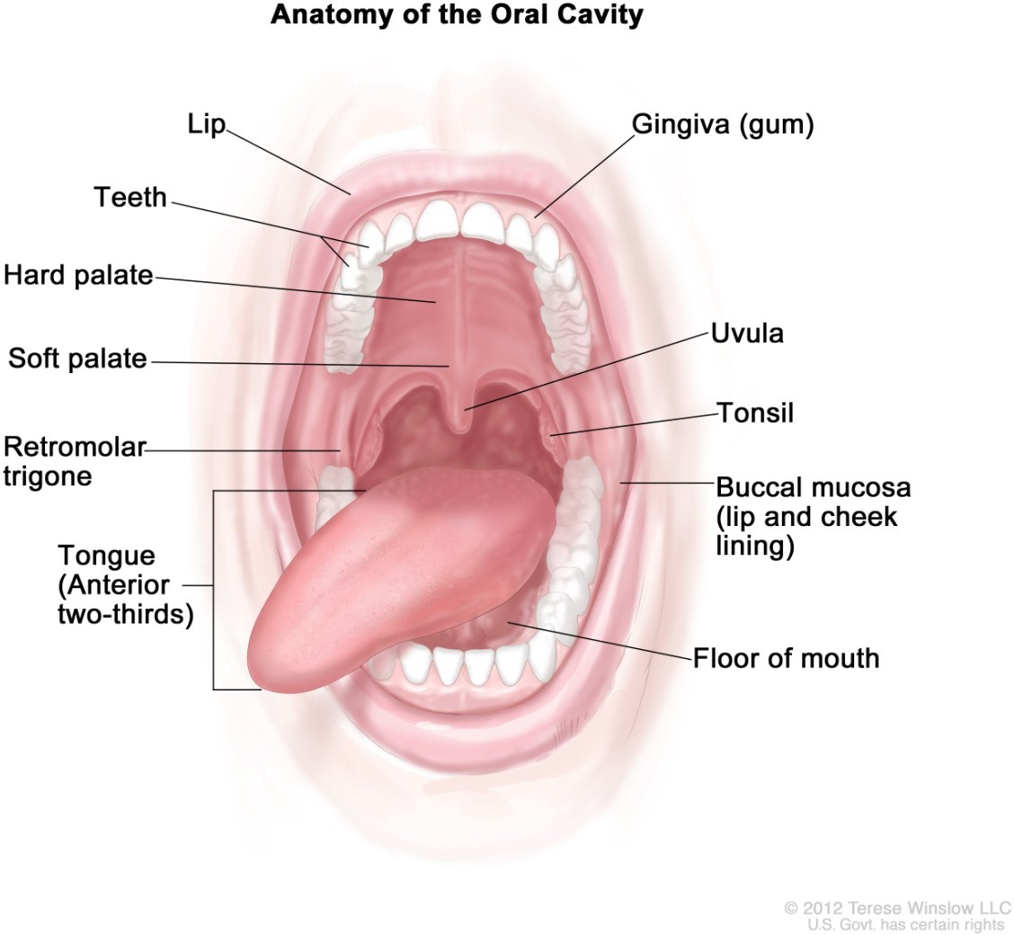

Figure 1: Anatomic sites and subsites for lip and oral cavity.

* The vermilion/dry lip is considered cutaneous.
* The uvula and soft palate and tonsil are considered oropharynx.

**Note 2 – Tumour dimensions**

Tumour dimension is an important component in pathologic staging.16,17 If available, measurements are made on fresh tissue. The macroscopic diameter (in millimetres) should be used unless the histological extent is greater than macroscopically apparent, in which case the microscopic dimension is used. At times only microscopic evaluation differentiates what clinically appears to be tumour from what is actual invasion (not dysplasia or inflammation). At least the greatest tumour dimension should be reported; preferably all three dimensions should be evaluated. Measurements are made pragmatically, acknowledging distortion of tissues by fixation and processing.18

**Note 3 – Histological tumour type**

All tumours of the oral cavity should be given a type based on the most recent edition of the WHO Classification of Head and Neck Tumours, 5th edition, 2024 (Table 1).4 The major histologic tumour types of SCC as recognised by the WHO classification are SCC, conventional type, basaloid, papillary, spindle, adenosquamous, acantholytic, lymphoepithelial, verrucous carcinoma and carcinoma cuniculatum. Hybrid lesions such as verrucous carcinoma and SCC exist and should be recognised as it may affect prognosis.

Subtypes should be assigned for both prognosis and cancer registry.19,20

Salivary gland carcinoma histologic type essentially defines its biologic behaviour and thus influences prognosis, patterns of recurrence and thus clinical management.21 Some carcinoma types (i.e., basal cell adenocarcinoma, conventional acinic cell carcinoma) are more indolent with locoregional recurrence but low nodal and distant metastatic rates.22 For guidance on histological typing of minor salivary gland carcinomas, please refer to the ICCR Carcinomas of the major salivary gland dataset.23

The classification and grading of neuroendocrine carcinomas (NEC) is discussed in **Note 4 HISTOLOGICAL TUMOUR GRADE**.

Table 1: World Health Organization classification of subtypes of squamous cell carcinoma of the oral cavity and mobile tongue.4

|  |  |
| --- | --- |
| **Descriptor** | **ICD-O codes**a |
| **Epithelial tumours and lesions** |  |
| Squamous cell carcinoma, conventional type | 8070/3 |
| Spindle cell (sarcomatoid) squamous cell carcinoma | 8074/3 |
| Basaloid squamous cell carcinoma | 8083/3 |
| Acantholytic squamous cell carcinoma | 8075/3 |
| Adenosquamous carcinoma | 8560/3 |
| Papillary squamous cell carcinoma | 8052/3 |
| Lymphoepithelial carcinoma | 8082/3 |
| Verrucous carcinoma | 8051/3 |
| Carcinoma cuniculatum | 8051/3 |
| **Epithelial neuroendocrine neoplasms** |  |
| Small cell neuroendocrine carcinoma | 8041/3 |
| Large cell neuroendocrine carcinoma | 8013/3 |
| Carcinoma mixed with small cell neuroendocrine carcinomab | 8045/3 |
| Carcinoma mixed with large cell neuroendocrine carcinomab | 8013/3 |

a These morphology codes are from the International Classification of Diseases for Oncology, third edition, second revision (ICD-0-3.2).24 Behaviour is coded /0 for benign tumours; /1 for unspecified, borderline, or uncertain behaviour:

/2 for carcinoma in situ and grade Ill intraepithelial neoplasia; /3 for malignant tumours, primary site: and /6 for malignant tumours, metastatic site. Behaviour code /6 is not generally used by cancer registries.

b This terminology is synonymous with the ICD-O terminology of combined small/large cell neuroendocrine carcinomas.

© World Health Organization/International Agency for Research on Cancer. Reproduced with permission.

**Note 4 – Histological tumour grade**

Based on the WHO classifications, three histologic grades of SCC, conventional type are used: well, moderately or poorly differentiated.4 The most aggressive or highest grade should be recorded if the tumour has a varied histology. Grading requires the assessment of keratinisation, mitotic activity, cellular and nuclear pleomorphism, pattern of invasion and host response.7,25-27 SCC subtypes are not graded. Still, several grading systems for each tumour type are available, with differing merits, and as such, recording which system has been applied is more clinically meaningfully (use ‘specify’ to state the system used), with the ICCR deferring to the WHO classification current edition for grading guidance and preference.4

Grading of minor salivary gland tumours follows the criteria for major salivary gland tumours.22,23

Neuroendocrine neoplasms, as newly defined,4 include paraganglioma/pheochromocytoma, neuroendocrine tumours, and NECs. Neuroendocrine tumours are separated into grades (1, 2, and 3) based on mitotic rate and Ki-67 proliferation indices, but these criteria are not yet fully developed for each of the anatomic sites in the head and neck. At present, the general cutoffs are: grade 1: <2 mitoses/2 millimetre (mm)2 and <2%

Ki-67 proliferation index; grade 2: ≥2-10 mitoses/2 mm2 and 2-20% Ki-67 proliferation index; grade 3: ≥11 mitoses/2 mm2 and >20% Ki-67 proliferation index.28,29 Further, NECs are separated into small cell and large cell categories, showing tumour necrosis, >10 mitoses/2 mm2 and >20% Ki-67 proliferation index,28,30-32 with universal Rb1 loss and common p53 overexpression.33 At present, the site, tumour category, and grade (non- core) should be reported, with additional advances in this field incorporated when validated further.

**Note 5 – Worst pattern of invasion**

Worst pattern of invasion (WPOI) has been validated as a prognosticator for oral cavity squamous carcinomas. While there are 5 patterns noted, distinction between WPOI-5 and other patterns is what is most relevant. WPOI-5 is defined by tumor dispersion ≥ 1mm between tumor satellites. Examples of pattern 5 are shown in the figures below. WPOI has been validated on multivariate analysis in oral tumors, also specifically in low stage tumors. However, WPOI can be viewed as redundant and only optional for reporting purposes as extramural perineural invasion (PNI), and angiolymphatic invasion also count as WPOI-5.

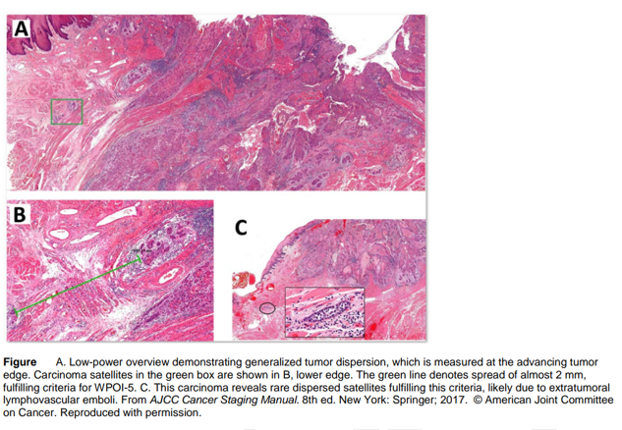

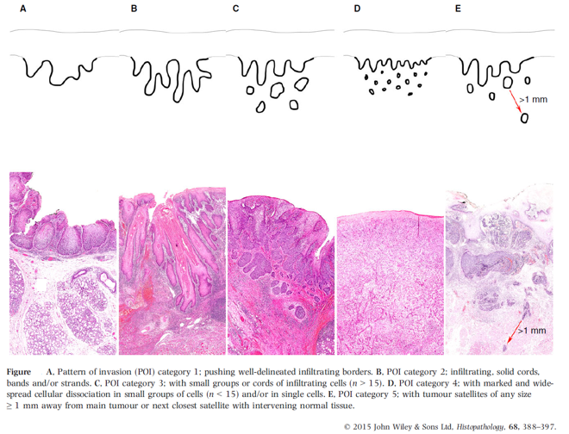

**Note 6 – Depth of invasion**

Depth of invasion (DOI) in OSCC, particularly of the tongue, has been identified as an important prognostic indicator, and is therefore a core element. The Union for International Cancer Control (UICC)/American Joint Committee on Cancer (AJCC) TNM staging systems incorporate DOI in determining the tumour stage (T).16,17,34 DOI increases T by 1 step for every 5 mm, whereby T1 is tumour ≤20 mm (≤2 centimetres (cm)) and DOI ≤5 mm, T2 is tumour ≤20 mm (≤2 cm) and DOI >5 mm and ≤10 mm, T3 tumour is >20 mm (>2 cm) and

≤40 mm (≤4 cm) and >10 mm DOI and T4a is tumour >40 mm (>4 cm) or any tumour >10 mm DOI. DOI measures the invasiveness of the carcinoma. To measure DOI, the basement membrane is identified, and an imaginary line is drawn across the tumour. A vertical or ‘plumb line’ extends to the deepest part of the tumour which represents the DOI. When the tumour is widely dispersed (see **Note 6 – PATTERN OF INVASIVE FRONT**), the measurement should be from the most distance tumour nest. It is important to note that DOI is not synonymous with tumour thickness. An exophytic tumour (Figure 2A) may be thicker than an ulcerative tumour (Figure 2B), but the DOI of the ulcerative lesion may be greater.35,36

The maximum DOI should be recorded as core and the discussion should include how/why DOI is different than tumour thickness.18,37-39

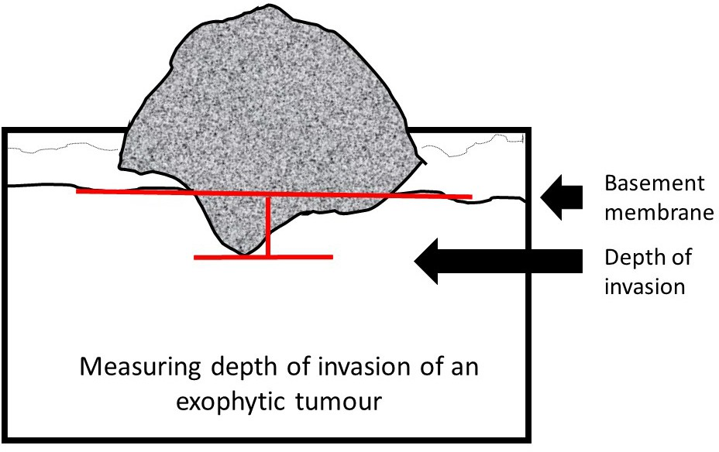

Figure 2A: Measuring depth of invasion.

© 2024 International Collaboration on Cancer Reporting Limited (ICCR).

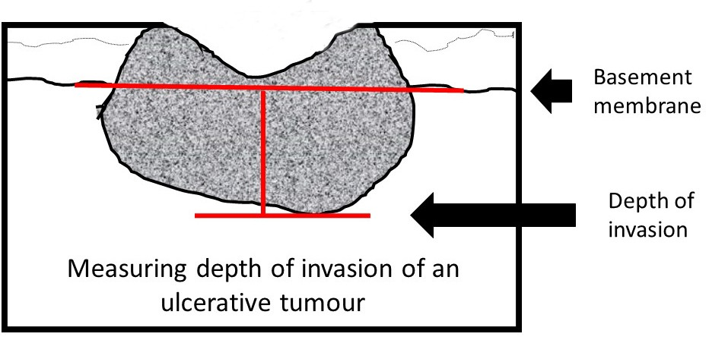

Figure 2B: Measuring depth of invasion.

© 2024 International Collaboration on Cancer Reporting Limited (ICCR).

**Note 7 – Pattern of invasive front**

The pattern of invasion in OSCC has proven prognostic value and should be reported as cohesive or non- cohesive (Figure 3).25,40-43 It is important to evaluate the most complex area of tumour-stroma interface (‘worst’ area), usually at the advancing edge, and ideally assessment should only be made on resection specimens or excisional biopsies. Acknowledgement is made that at times non-surgical treatment decisions are made on incisional biopsy specimens only and consequently the best assessment of pattern of invasion should be noted. Cohesive invasion is defined as broad sheets of cancer cells and/or tumour nests of >15 tumour cells. Non-cohesive invasion shows a spectrum of appearances that includes narrow strands, small groups of ≤15 tumour cells and single infiltrating tumour cells.35,36 For stage T1/T2 OSCC, particularly those arising in the tongue, there is evidence that tumour satellites localised ≥1 mm away from the main tumour or nearest satellite (worst pattern of invasion WPOI-5) is a valid adverse prognostic factor.25,40-42,44

Additionally, tumour budding has emerged as a promising biomarker in various carcinomas, with early evidence suggesting that it is an independent adverse prognostic factor in carcinoma of the oral cavity.45-52

Tumour budding is defined as single tumour cells or clusters of up to four tumour cells at the invasive tumour front. There is no consensus yet how it should be assessed and graded in oral carcinoma. It has been recommended to count the number of buds in 2 mm2 high power field (HPF) (x40) after scanning 10 HPFs in areas showing maximal budding.53 Budding activity is graded as low if 1 to 14 buds per 2mm2 and high if ≥15 buds per 2 mm2 are counted.

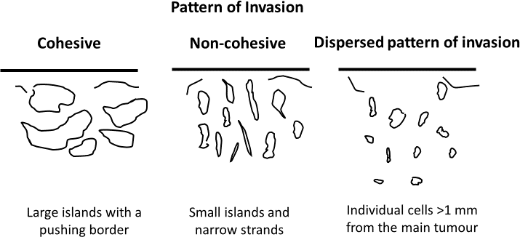

Figure 3: Pattern of Invasive front.

© 2024 International Collaboration on Cancer Reporting Limited (ICCR).

**Note 8 – Extent of invasion**

Infiltrative bone involvement by SCC correlates with a worse prognosis. Bone invasion may be a macroscopic feature, however sampling through the involved bone for histologic examination should be performed to obtain histologic evidence. The presence of bone invasion affects tumour staging and patients with bone invasion often have a worse prognosis. It is important to distinguish superficial cortical bone erosion from infiltrative invasion to the medullary bone as this is critical in accurate tumour staging. If bone is resected, then bone margins should be recorded.54 Tumour involvement of the maxillary sinus, and skin of the face and neck increases the pathological stage and should be noted.

**Note 9 – Lymphovascular invasion**

There is a need to distinguish between intravascular tumour embolization and retraction artefact. Positive lymphovascular invasion is a risk factor for decreased overall survival and should be reported only when tumour emboli are identified within endothelial lined spaces. No distinction between venous channels and small lymphatics is required.27,55,56

Cases that are still equivocal after taking additional steps may be reported as ‘indeterminate’ for lymphovascular invasion, but this designation should be sparingly used, and it is useful to provide the reason in a comment in the report.

**Note 10 – Perineural invasion**

Perineural invasion is associated with a worse prognosis, regardless of nerve size and should be recorded. The presence or absence of perineural and/or endoneural/intraneural invasion may impact subsequent therapy and prognosis.7,25,27,57

**Note 11 – Margin status**

All surgical margins should be measured in millimetres histologically for both mucosal and deep margins. In the comments section, acknowledgement should be made how the surgical margin was measured. For example, if the margin was submitted from the tumour bed margin at the time of the operative procedure rather than from the surgical specimen.58-60 The presence of severe dysplasia/carcinoma in situ at the margin is associated with an increased risk of local recurrence and this should be recorded. The definition of a ‘close’ margin is not standardised but in the oral cavity from a surgical point of view >5 mm is clear, and 1-5 mm is close, while <1 mm is involved. Acknowledgement is made of fixation and processing distortion on measurements which may cause tissue shrinkage including the surgical margin.61 Acknowledgement is also made of any laser or electrocautery associated tissue distortion such as cellular and nuclear polymorphism, nuclear hyperchromatism, epithelial cell separation, collagen denaturation, etc. on measurements including the surgical margin.62 Any bone resection margins should be identified and comment on the presence or absence of carcinoma at these margins should be provided.7,54 Dysplastic changes include abnormal cellular organisation, increased mitotic activity, and nuclear enlargement with pleomorphism.7,25,63,64 Although terminology varies, using the 2024 WHO criteria for oral dysplasia,4 dysplasia limited to the lower one-third of the epithelium is generally referred to as mild dysplasia. However, this can undercall higher dysplasia grades when both the architectural and cytological features of dysplasia are confined to the lower third depending on the individual features, such as tumour budding, bulbous rete and pleomorphism.4,9,65-67 Moderate dysplasia is defined as cytological atypia extending to the middle third of the epithelium and severe dysplasia extends to the upper third of the epithelium. Carcinoma in situ is considered synonymous with severe dysplasia.

Reporting of surgical margins for carcinomas of the minor salivary glands should follow those used for SCC of oral cavity.

**Note 12 – Ancillary studies**

For neuroendocrine neoplasms core elements are neuroendocrine markers, epithelial markers, and Ki-67 proliferation index. The diagnosis of neuroendocrine neoplasms (specifically NETs and NECs) must be confirmed immunohistochemically, with positive reaction for neuroendocrine markers (synaptophysin, chromogranin, INSM1) and for epithelial markers (pancytokeratin, cytokeratin). A proliferation index as determined by KI-67 immunohistochemical analysis is recommended for grading all NETs, and helping to confirm NECs. Both p53 and Rb1 may be helpful in distinguishing between NET and NEC, especially G3 NET from NEC.29,33,70

In most cases, further studies are not required for diagnosis of other tumours. Epithelial immuno- histochemical markers may be required for poorly differentiated or spindle cell carcinoma including AE1/ AE3, CK5/6, p63 and p40.71 Lymphoepithelial SCC in the oral cavity is rare and although not all cases are Epstein-Barr virus (EBV)-positive, EBV-encoded small RNAs (EBERs) studies are indicated.72 There is currently no role for routine HPV high risk type testing in OSCC.19,71 HPV-associated epithelial dysplasia requires in-situ hybridization/PCR confirmation.19

Programmed cell death-ligand 1 (PD-L1) expression has been used as predictive biomarker for checkpoint inhibitor therapy since the anti-programmed cell death-1 receptor (PD-1) antibodies, nivolumab and pembrolizumab, have been approved for the treatment of patients with recurrent and/or unresectable metastatic head and neck SSC,73-76 with various cutoffs of expression associated with betters responses, although not in all patients.77

**Note 13 – Pathological staging**

By UICC/AJCC convention,16,17 the designation ‘T’ refers to a primary tumour that has not been previously treated. The symbol ‘p’ refers to the pathologic classification of the stage, as opposed to the clinical classification, and is based on gross and microscopic examination. pT entails a resection of the primary tumour adequate to evaluate the highest pT category, pN entails removal of nodes adequate to validate lymph node metastasis, and pM implies microscopic examination of distant lesions. There is no pathologic M0 category as this designation requires clinical evaluation and imaging. Clinical classification (cTNM) is usually carried out by the evaluating clinician before treatment during initial evaluation of the patient or when pathologic classification is not possible.

Pathological staging is usually performed after surgical resection of the primary tumour and depends on documentation of the anatomic extent of disease, whether or not the primary tumour has been completely removed. If a biopsied tumour is not resected for any reason (e.g., when technically unfeasible) and if the highest T and N categories or the M1 category of the tumour can be confirmed microscopically, the criteria for pathologic classification and staging have been satisfied even though total removal of the primary cancer was not performed.

**Primary tumour (pT)**

TX Primary tumour cannot be assessed

Tis Carcinoma in situ

T1 Tumour 2 cm or less in greatest dimension and 5 mm or less depth of invasion

T2 Tumour 2 cm or less in greatest dimension and more than 5 mm depth of invasion or tumour more than 2 cm but not more than 4 cm in greatest dimension and depth of invasion no more than 10 mm

T3 Tumour more than 2 cm but not more than 4 cm in greatest dimension and depth of invasion more than 10 mm or tumour more than 4 cm in greatest dimension and not more than 10 mm depth of invasion

T4a (Lip) Tumour more than 4 cm in greatest dimension and more than 10 mm depth of invasion or tumour invades through cortical bone, inferior alveolar nerve, floor of mouth, or skin (of the chin or the nose)

T4a (Oral cavity) Tumour more than 4 cm in greatest dimension and more than 10 mm depth of invasion or tumour invades through the cortical bone of the mandible or maxilla or involves the maxillary sinus, or invades the skin of the face

T4b (Lip and oral cavity) Tumour invades masticator space, pterygoid plates, or skull base, or encases internal carotid artery

**TNM Descriptors**

For identification of special cases of TNM or pTNM classifications, the ‘m’ suffix and ‘y’ and ‘r’ prefixes are used. Although they do not affect the stage grouping, they indicate cases needing separate analysis.

The ‘m’ suffix indicates the presence of multiple primary tumours in a single site and is recorded in parentheses: pT(m)NM.

The ‘y’ prefix indicates those cases in which classification is performed during or following initial multimodality therapy (i.e., neoadjuvant chemotherapy, radiation therapy, or both chemotherapy and radiation therapy). The cTNM or pTNM category is identified by a ‘y’ prefix. The ycTNM or ypTNM categorises the extent of tumour actually present at the time of that examination. The ‘y’ categorisation is not an estimate of tumour prior to multimodality therapy (i.e., before initiation of neoadjuvant therapy).

The ‘r’ prefix indicates a recurrent tumour when staged after a documented disease-free interval, and is identified by the ‘r’ prefix: rTNM.

For the pN classification of regional lymph nodes, see ICCR Nodal excisions and neck dissection specimens dataset.3

Reporting of pathological staging categories (pT, pN, pM) is based on the evidence available to the pathologist at the time of reporting. As indicated in UICC TNM8 and AJCC TNM8,16,17 the final stage grouping of a patient's tumour is based on a combination of pathological staging and other clinical and imaging information.

Pathological staging should not be reported if the submitted specimen is insufficient for definitive staging, especially with biopsy samples (core needle, incisional or excisional). Staging is based on the submitted resection, and even if there is grossly residual disease or there is tumour at the margin, pT staging should only be reported on findings in the resection specimen and/or at operation.16,17

The reference document TNM Supplement: A commentary on uniform use, 5th Edition (C Wittekind et al. editors) may be of assistance when staging.78

Références

1. Merlin T, Weston A and Tooher R (2009). Extending an evidence hierarchy to include topics other than treatment: revising the Australian 'levels of evidence'. *BMC Med Res Methodol* 9:34.
2. International Collaboration on Cancer Reporting (2024). *ICCR Datasets*. Available from: https://[www.iccr-cancer.org/datasets/published-datasets/](http://www.iccr-cancer.org/datasets/published-datasets/) (Accessed 15th January 2024).
3. International Collaboration on Cancer Reporting (2024). *Nodal Excisions and Neck Dissection Specimens for Head & Neck Tumours Histopathology Reporting Guide. 2nd edition*. Available from: https://[www.iccr-cancer.org/datasets/published-datasets/head-neck/nodal-excisions/](http://www.iccr-cancer.org/datasets/published-datasets/head-neck/nodal-excisions/) (Accessed 31st July 2024).
4. WHO Classification of Tumours Editorial Board (2024). *Head and Neck Tumours, WHO Classification of Tumours, 5th Edition, Volume 10*. IARC Press, Lyon.
5. Koike K, Ohashi N, Nishiyama K, Okamoto J, Sasaki T, Ogi K, Dehari H, Hirokawa N, Someya M, Saito M, Okuda H, Otani A, Sonoda T, Sugawara T, Hasegawa T, Hiratsuka H, Sakata KI and Miyazaki A (2022). Clinical and histopathologic effects of neoadjuvant intra-arterial chemoradiotherapy with cisplatin in combination with oral S-1 on stage III and IV oral cancer. *Oral Surg Oral Med Oral Pathol Oral Radiol* 134(3):347-353.
6. Olmos M, Glajzer J, Büntemeyer TO, Frohwitter G, Ries J, Eckstein M, Hecht M, Lutz R, Kesting MR and Weber M (2021). Neoadjuvant Immunotherapy of Oral Squamous Cell Carcinoma: Case Report and Assessment of Histological Response. *Front Oncol* 11:720951.
7. Bonert M, Zafar U, Williams P, El-Shinnawy I, Juergens RA, Naqvi A, Cutz JC, Finley C, Major P and Kapoor A (2022). Physician and Surgeon Communication Assessed via the Pathology Requisition in a Regional Laboratory Over Ten Years. *Cureus* 14(8):e27714.
8. Rapidis AD, Gullane P, Langdon JD, Lefebvre JL, Scully C and Shah JP (2009). Major advances in the knowledge and understanding of the epidemiology, aetiopathogenesis, diagnosis, management and prognosis of oral cancer. *Oral Oncol* 45(4-5):299-300.
9. Shah JP and Gil Z (2009). Current concepts in management of oral cancer--surgery. *Oral Oncol* 45(4- 5):394-401.
10. Nakhleh RE (2011). Quality in surgical pathology communication and reporting. *Arch Pathol Lab Med*

135(11):1394-1397.

1. Nakhleh RE, Myers JL, Allen TC, DeYoung BR, Fitzgibbons PL, Funkhouser WK, Mody DR, Lynn A, Fatheree LA, Smith AT, Lal A and Silverman JF (2012). Consensus statement on effective communication of urgent diagnoses and significant, unexpected diagnoses in surgical pathology and cytopathology from the College of American Pathologists and Association of Directors of Anatomic and Surgical Pathology. *Arch Pathol Lab Med* 136(2):148-154.
2. Yung AE, Que MS, Lo S, Aggarwal S, Hong AM, Tin MM, Clark JR, Gupta R and Ch'ng S (2021). Validation of the American Joint Committee on Cancer Staging in Squamous Cell Carcinoma of the Vermilion Lip. *Ann Surg Oncol* 28(6):3092-3099.
3. Bresadola L, Weber D, Ritzel C, Löwer M, Bukur V, Akilli-Öztürk Ö, Becker J, Mehanna H, Schrörs B, Vascotto F, Sahin U and Kong A (2021). Comprehensive Genomic and Transcriptomic Analysis of Three Synchronous Primary Tumours and a Recurrence from a Head and Neck Cancer Patient. *Int J Mol Sci* 22(14):7583.
4. Feng Z, Xu QS, Niu QF, Qin LZ, Li JZ, Su M, Li H and Han Z (2016). Risk factors for patients with multiple synchronous primary cancers involving oral and oropharyngeal subsites. *Oral Surg Oral Med Oral Pathol Oral Radiol* 121(4):360-366.
5. Thompson LDR, Fitzpatrick SG, Müller S, Eisenberg E, Upadhyaya JD, Lingen MW, Vigneswaran N, Woo SB, Bhattacharyya I, Bilodeau EA, Carlos R, Islam MN, Leon ME, Lewis JS, Jr., Magliocca KR, Mani H, Mehrad M, Purgina B, Richardson M, Wenig BM and Cohen DM (2021). Proliferative Verrucous Leukoplakia: An Expert Consensus Guideline for Standardized Assessment and Reporting. *Head Neck Pathol* 15(2):572-587.
6. Brierley JD, Gospodarowicz MK and Wittekind C (eds) (2016). *Union for International Cancer Control. TNM Classification of Malignant Tumours, 8th Edition*, Wiley, USA.
7. Amin MB, Edge SB, Greene FL, Byrd DR, Brookland RK, Washington MK, Gershenwald JE, Compton CC, Hess KR, Sullivan DC, Jessup JM, Brierley JD, Gaspar LE, Schilsky RL, Balch CM, Winchester DP, Asare EA, Madera M, Gress DM and Meyer LR (eds) (2017). *AJCC Cancer Staging Manual. 8th ed.*, Springer, New York.
8. Burns C and Gorina Faz M (2021). An Analysis of Tumor Margin Shrinkage in the Surgical Resection of Squamous Cell Carcinoma of the Oral Cavity. *Cureus* 13(5):e15329.
9. Muller S and Tilakaratne WM (2022). Update from the 5th Edition of the World Health Organization Classification of Head and Neck Tumors: Tumours of the Oral Cavity and Mobile Tongue. *Head Neck Pathol* 16(1):54-62.
10. Abé T, Yamazaki M, Maruyama S, Ikeda N, Sumita Y, Tomihara K and Tanuma JI (2022). Adenosquamous Carcinoma with the Acantholytic Feature in the Oral Cavity: A Case Report and Comprehensive Literature Review. *Diagnostics (Basel)* 12(10):2398.
11. Dos Santos ES, Rodrigues-Fernandes CI, Speight PM, Khurram SA, Alsanie I, Costa Normando AG, Prado-Ribeiro AC, Brandão TB, Kowalski LP, Silva Guerra EN, Lopes MA, Vargas PA, Santos-Silva AR and Leme AFP (2021). Impact of tumor site on the prognosis of salivary gland neoplasms: A systematic review and meta-analysis. *Crit Rev Oncol Hematol* 162:103352.
12. Ihrler S, Agaimy A, Guntinas-Lichius O, Haas CJ, Mollenhauer M, Sandison A and Greber L (2021). Why is the histomorphological diagnosis of tumours of minor salivary glands much more difficult? *Histopathology* 79(5):779-790.
13. International Collaboration on Cancer Reporting (2024). *Carcinomas of the major salivary glands Histopathology Reporting Guide. 2nd edition*. Available from: [https://www.iccr-](https://www.iccr-cancer.org/datasets/published-datasets/head-neck/salivary-glands/) [cancer.org/datasets/published-datasets/head-neck/salivary-glands/](https://www.iccr-cancer.org/datasets/published-datasets/head-neck/salivary-glands/) (Accessed 31st July 2024).
14. Fritz A, Percy C, Jack A, Shanmugaratnam K, Sobin L, Parkin DM and Whelan S (eds) (2020). *International Classification of Diseases for Oncology, Third edition, Second revision ICD-O-3.2*. Available from: <http://www.iacr.com.fr/index.php?option=com_content&view=category&layout=blog&id=100&Ite> mid=577 (Accessed 16th March 2024).
15. Elseragy A, Bello IO, Wahab A, Coletta RD, Mäkitie AA, Leivo I, Almangush A and Salo T (2022). Emerging histopathologic markers in early-stage oral tongue cancer: A systematic review and meta- analysis. *Head Neck* 44(6):1481-1491.
16. Choi YS, Kim MG, Lee JH, Park JY and Choi SW (2022). Analysis of prognostic factors through survival rate analysis of oral squamous cell carcinoma patients treated at the National Cancer Center: 20 years of experience. *J Korean Assoc Oral Maxillofac Surg* 48(5):284-291.
17. Dolens EDS, Dourado MR, Almangush A, Salo TA, Gurgel Rocha CA, da Silva SD, Brennan PA and Coletta RD (2021). The Impact of Histopathological Features on the Prognosis of Oral Squamous Cell Carcinoma: A Comprehensive Review and Meta-Analysis. *Front Oncol* 11:784924.
18. Bal M, Sharma A, Rane SU, Mittal N, Chaukar D, Prabhash K and Patil A (2022). Neuroendocrine Neoplasms of the Larynx: A Clinicopathologic Analysis of 27 Neuroendocrine Tumors and Neuroendocrine Carcinomas. *Head Neck Pathol* 16(2):375-387.
19. Asa SL, Arkun K, Tischler AS, Qamar A, Deng FM, Perez-Ordonez B, Weinreb I, Bishop JA, Wenig BM and Mete O (2021). Middle Ear "Adenoma": a Neuroendocrine Tumor with Predominant L Cell Differentiation. *Endocr Pathol* 32(4):433-441.
20. Rivero A and Liang J (2016). Sinonasal small cell neuroendocrine carcinoma: a systematic review of 80 patients. *Int Forum Allergy Rhinol* 6(7):744-751.
21. Kuan EC, Alonso JE, Tajudeen BA, Arshi A, Mallen-St Clair J and St John MA (2017). Small cell carcinoma of the head and neck: A comparative study by primary site based on population data. *Laryngoscope* 127(8):1785-1790.
22. van der Laan TP, Iepsma R, Witjes MJ, van der Laan BF, Plaat BE and Halmos GB (2016). Meta- analysis of 701 published cases of sinonasal neuroendocrine carcinoma: The importance of differentiation grade in determining treatment strategy. *Oral Oncol* 63:1-9.
23. Uccella S, La Rosa S, Metovic J, Marchiori D, Scoazec JY, Volante M, Mete O and Papotti M (2021). Genomics of High-Grade Neuroendocrine Neoplasms: Well-Differentiated Neuroendocrine Tumor with High-Grade Features (G3 NET) and Neuroendocrine Carcinomas (NEC) of Various Anatomic Sites. *Endocr Pathol* 32(1):192-210.
24. Bresciani L, Giannini L, Paderno A, Incandela F, Fontanella W, Mattavelli D and Piazza C (2021). Comparison of Different Staging Systems Applied to a Cohort of Patients With Oral Tongue and Floor of the Mouth Cancer. *Front Oral Health* 2:737329.
25. Almangush A, Bello IO, Coletta RD, Makitie AA, Makinen LK, Kauppila JH, Pukkila M, Hagstrom J, Laranne J, Soini Y, Kosma VM, Koivunen P, Kelner N, Kowalski LP, Grenman R, Leivo I, Laara E and Salo T (2015). For early-stage oral tongue cancer, depth of invasion and worst pattern of invasion are the strongest pathological predictors for locoregional recurrence and mortality. *Virchows Arch* 467(1):39-46.
26. Almangush A, Bello IO, Keski-Santti H, Makinen LK, Kauppila JH, Pukkila M, Hagstrom J, Laranne J, Tommola S, Nieminen O, Soini Y, Kosma VM, Koivunen P, Grenman R, Leivo I and Salo T (2014). Depth of invasion, tumor budding, and worst pattern of invasion: prognostic indicators in early-stage oral tongue cancer. *Head Neck* 36(6):811-818.
27. Dhanda J, Uppal N, Chowlia H, Opie N, Al-Qamachi L, Shelat D, Aslam A, Yuffa A, Martin T, Risk J, Triantafyllou A, Shaw R, Parmar S and Mehanna H (2016). Features and prognostic utility of biopsy in oral squamous cell carcinoma. *Head Neck* 38 Suppl 1:E1857-1862.
28. Dang RR, Kim J, Qureshi MM, Fazeli SR, Zhao Q, Noonan VL, Sundararajan D, Salama A and Truong MT (2023). Impact of depth of invasion on local recurrence in R0 resected node-negative oral tongue squamous cell carcinoma. *Head Neck* 45(3):561-566.
29. Kligerman MP, Moon PK, Tusty M, Cloutier JM, Ma Y, Holsinger CF and Divi V (2023). Impact of Histologic Risk Factors on Recurrence Rates for Oral Cavity Squamous Cell Carcinoma. *Ann Otol Rhinol Laryngol* 132(7):731-737.
30. Xu B, Salama AM, Valero C, Yuan A, Khimraj A, Saliba M, Zanoni DK, Ganly I, Patel SG, Katabi N and Ghossein R (2021). The prognostic role of histologic grade, worst pattern of invasion, and tumor budding in early oral tongue squamous cell carcinoma: a comparative study. *Virchows Arch* 479(3):597-606.
31. Chatterjee D, Bansal V, Malik V, Bhagat R, Punia RS, Handa U, Gupta A and Dass A (2019). Tumor Budding and Worse Pattern of Invasion Can Predict Nodal Metastasis in Oral Cancers and Associated With Poor Survival in Early-Stage Tumors. *Ear Nose Throat J* 98(7):E112-e119.
32. Mäkitie AA, Almangush A, Rodrigo JP, Ferlito A and Leivo I (2019). Hallmarks of cancer: Tumor budding as a sign of invasion and metastasis in head and neck cancer. *Head Neck* 41(10):3712-3718.
33. Beute JE, Greenberg LA, Wein LE, Kapustin DA, Fan J, Dowling EM, Samankan S, Matloob A, Xing M, Modica I, Chung D, Carroll W, Rosenthal EL, Khan MN, Chai RL, Brandwein-Weber MS and Urken ML (2023). WPOI-5: Accurately Identified at Intraoperative Consultation and Predictive of Occult Cervical Metastases. *Head Neck Pathol* 17(2):479-486.
34. Mishra A, Das A, Dhal I, Shankar R, Bhavya BM, Singh N, Tripathi P, Daga D, Rai A, Gupta M and Sahu GC (2022). Worst pattern of invasion in oral squamous cell carcinoma is an independent prognostic factor. *J Oral Biol Craniofac Res* 12(6):771-776.
35. Sarode GS, Sarode SC, Deshmukh R, Anand R and Patil S (2017). Tumor Budding in Oral Squamous Cell Carcinoma. *J Contemp Dent Pract* 18(9):743-744.
36. Shimizu S, Miyazaki A, Sonoda T, Koike K, Ogi K, Kobayashi JI, Kaneko T, Igarashi T, Ueda M, Dehari H, Miyakawa A, Hasegawa T and Hiratsuka H (2018). Tumor budding is an independent prognostic marker in early stage oral squamous cell carcinoma: With special reference to the mode of invasion and worst pattern of invasion. *PLoS One* 13(4):e0195451.
37. Hong KO, Oh KY, Shin WJ, Yoon HJ, Lee JI and Hong SD (2018). Tumor budding is associated with poor prognosis of oral squamous cell carcinoma and histologically represents an epithelial- mesenchymal transition process. *Hum Pathol* 80:123-129.
38. Xie N, Yu P, Liu H, Liu X, Hou J, Chen X, Huang H and Wang C (2019). Validation of the International Tumor Budding Consensus Conference (2016) recommendations in oral tongue squamous cell carcinoma. *J Oral Pathol Med* 48(6):451-458.
39. Bjerkli IH, Laurvik H, Nginamau ES, Søland TM, Costea D, Hov H, Uhlin-Hansen L, Hadler-Olsen E and Steigen SE (2020). Tumor budding score predicts lymph node status in oral tongue squamous cell carcinoma and should be included in the pathology report. *PLoS One* 15(9):e0239783.
40. Hori Y, Kubota A, Yokose T, Furukawa M, Matsushita T, Katsumata N and Oridate N (2021). Prognostic Role of Tumor-Infiltrating Lymphocytes and Tumor Budding in Early Oral Tongue Carcinoma. *Laryngoscope* 131(11):2512-2518.
41. Joshi P, Pol J, Chougule M, Jadhav K, Patil S and Patil S (2020). Tumor budding - A promising prognostic histopathological parameter in oral squamous cell carcinoma - A comparative immunohistochemical study. *J Oral Maxillofac Pathol* 24(3):587.
42. Noda Y, Ishida M, Ueno Y, Fujisawa T, Iwai H and Tsuta K (2022). Novel pathological predictive factors for extranodal extension in oral squamous cell carcinoma: a retrospective cohort study based on tumor budding, desmoplastic reaction, tumor-infiltrating lymphocytes, and depth of invasion. *BMC Cancer* 22(1):402.
43. Boxberg M, Kuhn PH, Reiser M, Erb A, Steiger K, Pickhard A, Straßen U, Koob I, Kolk A, Warth A, Jesinghaus M and Weichert W (2019). Tumor Budding and Cell Nest Size Are Highly Prognostic in Laryngeal and Hypopharyngeal Squamous Cell Carcinoma: Further Evidence for a Unified Histopathologic Grading System for Squamous Cell Carcinomas of the Upper Aerodigestive Tract. *Am J Surg Pathol* 43(3):303-313.
44. Singh A, Mair M, Singhvi H, Mahuvakar A, Nair D, Nair S and Chaturvedi P (2019). Incidence, predictors and impact of positive bony margins in surgically treated T4 stage cancers of the oral cavity. *Oral Oncol* 90:8-12.
45. Comer JC, Harris AB, Hess AO, Hitchcock KE, Mendenhall WM, Bates JE and Dziegielewski PT (2023). Does lymphovascular invasion predict survival in oral cancer? A population-based analysis. *Oral Oncol* 140:106387.
46. Mascitti M, Togni L, Caponio VCA, Zhurakivska K, Bizzoca ME, Contaldo M, Serpico R, Lo Muzio L and Santarelli A (2022). Lymphovascular invasion as a prognostic tool for oral squamous cell carcinoma: a comprehensive review. *Int J Oral Maxillofac Surg* 51(1):1-9.
47. Mäkitie AA, Agaimy A and Almangush A (2022). Insight into Classification and Risk Stratification of Head and Neck Squamous Cell Carcinoma in Era of Emerging Biomarkers with Focus on Histopathologic Parameters. *Cancers (Basel)* 14(22):5514.
48. Higginson JA, Breik O, Thompson AH, Ashrafian H, Hardman JC, Takats Z, Paleri V and Dhanda J (2023). Diagnostic accuracy of intraoperative margin assessment techniques in surgery for head and neck squamous cell carcinoma: A meta-analysis. *Oral Oncol* 142:106419.
49. MacKay C, Turner B, Bullock M, Taylor SM, Trites J, Corsten M, Geldenhuys L and Rigby MH (2022). Margin Sampling and Survival Outcomes in Oral Cavity and p16-Positive Oropharyngeal Squamous Cell Carcinoma. *OTO Open* 6(3):2473974x221101024.
50. Chiosea SI (2017). Intraoperative Margin Assessment in Early Oral Squamous Cell Carcinoma. *Surg Pathol Clin* 10(1):1-14.
51. K K, Kamboj V, Sreedharan S, S VS, Rai T and Kabekkodu S (2022). Effect of formalin fixation on tumour size and margins in head and neck cancer specimens. *Acta Otorhinolaryngol Ital* 42(5):434- 440.
52. Tenore G, Mohsen A, Nuvoli A, Palaia G, Rocchetti F, Di Gioia CRT, Cicconetti A, Romeo U and Del Vecchio A (2023). The Impact of Laser Thermal Effect on Histological Evaluation of Oral Soft Tissue Biopsy: Systematic Review. *Dent J (Basel)* 11(2):28.
53. Puram SV, Mays AC, Bayon R, Bell D, Chung J, Fundakowski CE, Johnson BT, Massa ST, Sharma A and Varvares MA (2023). Margins in Stage I and II Oral Cavity Squamous Cell Carcinoma: A Review From the American Head and Neck Society. *JAMA Otolaryngol Head Neck Surg* 149(7):636-642.
54. Long SM, McLean T, Valero Mayor C, Fitzgerald CWR, Feit NZ, Katabi N, Xu B, Cohen MA, Ganly I, Ghossein RA and Patel SG (2022). Use of Intraoperative Frozen Section to Assess Final Tumor Margin Status in Patients Undergoing Surgery for Oral Cavity Squamous Cell Carcinoma. *JAMA Otolaryngol Head Neck Surg* 148(10):911-917.
55. Wolk R and Lingen MW (2023). Proceedings of the North American Society of Head and Neck Pathology Companion Meeting, New Orleans, LA, March 12, 2023: Oral Cavity Dysplasia: Why Does Histologic Grading Continue to be Contentious? *Head Neck Pathol* 17(2):292-298.
56. Sperandio M, Warnakulasuriya S, Soares AB, Passador-Santos F, Mariano FV, Lima CSP, Scarini JF, Dominguete MHL, de Camargo Moraes P, Montalli VAM, Hellmeister L and de Araújo VC (2023). Oral epithelial dysplasia grading: Comparing the binary system to the traditional 3-tier system, an actuarial study with malignant transformation as outcome. *J Oral Pathol Med* 52(5):418-425.
57. Odell E, Kujan O, Warnakulasuriya S and Sloan P (2021). Oral epithelial dysplasia: Recognition, grading and clinical significance. *Oral Dis* 27(8):1947-1976.
58. Kujan O, Mello FW and Warnakulasuriya S (2021). Malignant transformation of oral submucous fibrosis: A systematic review and meta-analysis. *Oral Dis* 27(8):1936-1946.
59. Gervazio TC, Silva JK, Evangelista K, Cavalcanti MGP, Silva M, Yamamoto-Silva FP and Silva BSF (2022). Risk of oral cancer in patients with graft-vs-host disease: A systematic review and meta- analysis. *Oral Surg Oral Med Oral Pathol Oral Radiol* 133(6):650-662.
60. Rindi G, Klimstra DS, Abedi-Ardekani B, Asa SL, Bosman FT, Brambilla E, Busam KJ, de Krijger RR, Dietel M, El-Naggar AK, Fernandez-Cuesta L, Klöppel G, McCluggage WG, Moch H, Ohgaki H, Rakha EA, Reed NS, Rous BA, Sasano H, Scarpa A, Scoazec JY, Travis WD, Tallini G, Trouillas J, van Krieken JH and Cree IA (2018). A common classification framework for neuroendocrine neoplasms: an International Agency for Research on Cancer (IARC) and World Health Organization (WHO) expert consensus proposal. *Mod Pathol* 31(12):1770-1786.
61. Zidar N and Gale N (2022). Update from the 5th Edition of the World Health Organization Classification of Head and Neck Tumors: Hypopharynx, Larynx, Trachea and Parapharyngeal Space. *Head Neck Pathol* 16(1):31-39.
62. Wenig BM (2015). Lymphoepithelial-like carcinomas of the head and neck. *Semin Diagn Pathol*

32(1):74-86.

1. Ferris RL, Blumenschein G, Jr., Fayette J, Guigay J, Colevas AD, Licitra L, Harrington K, Kasper S, Vokes EE, Even C, Worden F, Saba NF, Iglesias Docampo LC, Haddad R, Rordorf T, Kiyota N, Tahara M, Monga M, Lynch M, Geese WJ, Kopit J, Shaw JW and Gillison ML (2016). Nivolumab for Recurrent Squamous-Cell Carcinoma of the Head and Neck. *N Engl J Med* 375(19):1856-1867.
2. Cohen EEW, Soulières D, Le Tourneau C, Dinis J, Licitra L, Ahn MJ, Soria A, Machiels JP, Mach N, Mehra R, Burtness B, Zhang P, Cheng J, Swaby RF and Harrington KJ (2019). Pembrolizumab versus methotrexate, docetaxel, or cetuximab for recurrent or metastatic head-and-neck squamous cell carcinoma (KEYNOTE-040): a randomised, open-label, phase 3 study. *Lancet* 393(10167):156-167.
3. Seiwert TY, Burtness B, Mehra R, Weiss J, Berger R, Eder JP, Heath K, McClanahan T, Lunceford J, Gause C, Cheng JD and Chow LQ (2016). Safety and clinical activity of pembrolizumab for treatment of recurrent or metastatic squamous cell carcinoma of the head and neck (KEYNOTE-012): an open- label, multicentre, phase 1b trial. *Lancet Oncol* 17(7):956-965.
4. Burtness B, Harrington KJ, Greil R, Soulières D, Tahara M, de Castro G, Jr., Psyrri A, Basté N, Neupane P, Bratland Å, Fuereder T, Hughes BGM, Mesía R, Ngamphaiboon N, Rordorf T, Wan Ishak WZ, Hong RL, González Mendoza R, Roy A, Zhang Y, Gumuscu B, Cheng JD, Jin F and Rischin D (2019). Pembrolizumab alone or with chemotherapy versus cetuximab with chemotherapy for recurrent or metastatic squamous cell carcinoma of the head and neck (KEYNOTE-048): a randomised, open- label, phase 3 study. *Lancet* 394(10212):1915-1928.
5. Litchfield K, Reading JL, Puttick C, Thakkar K, Abbosh C, Bentham R, Watkins TBK, Rosenthal R, Biswas D, Rowan A, Lim E, Al Bakir M, Turati V, Guerra-Assunção JA, Conde L, Furness AJS, Saini SK, Hadrup SR, Herrero J, Lee SH, Van Loo P, Enver T, Larkin J, Hellmann MD, Turajlic S, Quezada SA, McGranahan N and Swanton C (2021). Meta-analysis of tumor- and T cell-intrinsic mechanisms of sensitization to checkpoint inhibition. *Cell* 184(3):596-614.e514.
6. Wittekind C, Brierley JD, van Eycken AL and van Eycken E (eds) (2019). *TNM Supplement: A Commentary on Uniform Use, 5th Edition*, Wiley, USA.

1. En cas de néoplasie des glandes salivaires accessoires, l'option "Carcinome des glandes salivaires (spécifiez)" doit être sélectionnée. Le sous-type histologique peut ensuite être précisé selon la liste incluse dans le rapport standard "Glandes salivaires principales".
2. La profondeur d’invasion fait référence à la tumeur invasive, indépendamment d’une composante exophytique. Elle est mesurée en déterminant “l’horizon” de la membrane basale de l’épithélium pavimenteux adjacent. Une “plumb line” perpendiculaire est tracée à partir de cet “horizon”, et ce jusqu’au point le plus profond de la tumeur invasive (profondeur d’invasion). Pour plus d’informations, voir ‘Note 6 – Depth of invasion’ plus bas dans ce document.
3. La présence d’une invasion osseuse influence le stade de la tumeur et constitue un facteur pronostic négatif. Il est important de faire la distinction entre de l’érosion osseuse corticale et de l’invasion infiltrante de la moëlle osseuse, car l’érosion osseuse n’affectera pas les soins futurs. Pour plus d’informations, voir ‘Note 8 – Extent of invasion’ plus bas dans ce document.
4. La présence ou absence d’invasion périneurale péritumorale peut avoir une influence sur le traitement et le pronostic. Il s’agit d’une invasion périneurale péritumorale le long ou au-delà des limites de la tumeur, et donc pas d’une extension intratumorale. Pour plus d’informations, voir ‘Note 10 – Perineural invasion’ plus bas dans ce document.
5. La définition des “Marges minimales définitives saines” n’est pas standardisée, mais dans la cavité orale, d’un point de vue chirurgical, <1 mm est positif, 1-5 mm est ‘close’ et >5 mm est ‘clear’. La présence de dysplasie sévère/carcinome in situ au niveau de la plan de coupe est associée à un risque accru de récidive locale, et cela doit également être enregistré. Pour plus d’informations, voir ‘Note 11 – Margin status’ plus bas dans ce document.
6. La définition des “Marges minimales définitives saines” n’est pas standardisée, mais dans la cavité orale, d’un point de vue chirurgical, <1 mm est positif, 1-5 mm est ‘close’ et >5 mm est ‘clear’. La présence de dysplasie sévère/carcinome in situ au niveau de la plan de coupe est associée à un risque accru de récidive locale, et cela doit également être enregistré. Pour plus d’informations, voir ‘Note 11 – Margin status’ plus bas dans ce document.
7. La stadification pathologique est basée sur la «TNM Classification of Malignant Tumours» (8e édition, UICC). Une description de chaque catégorie pT est disponible dans la «Note 13 – Pathological staging» plus bas dans ce document.
8. Information complémentaires (‘notes’) reprises et adaptées de

   Müller S, Day TA, Griffith CC, Magliocca KR, Mori T, Richardson MS, Sloan P, Tilakaratne WM, Zain RB, Helliwell T, Thompson LDR (2024). *Carcinomas of the Oral Cavity Histopathology Reporting Guide. 2nd edition*. International Collaboration on Cancer Reporting; Sydney, Australia. ISBN: 978-1-922324-45-0.